Attrections in New York

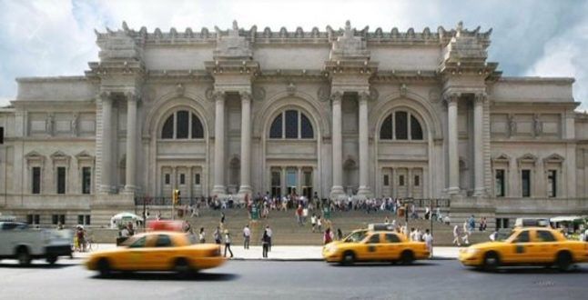  Metropolitan Museum of Art | The art collection of 'the Met' is one of the world's most extensive, ranging from prehistoric to modern times. It is housed in a monumental Beaux-Arts building in Central Park.  Days and Times: For The Met Breuer from 10.00 to 21.00; for The Met Fifth Avenue from 10.00 to 21.00; for The Met Cloister from 10.00 to 16.45  Prices: $25 for adults; $17 for seniors; $12 for students; free for the children under 12.
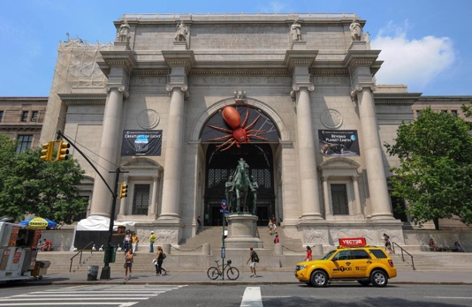  Museum of Natural History | This large museum near Central Park is one of New York's most popular with attractions ranging from dinosaur skeletons to biodiversity exhibitions and a planetarium.  Days and Times: Every day from 10.00 to 17.45  Prices: For the adult $23; for the children (2-12 years ago) $13; for the senior and student $18.
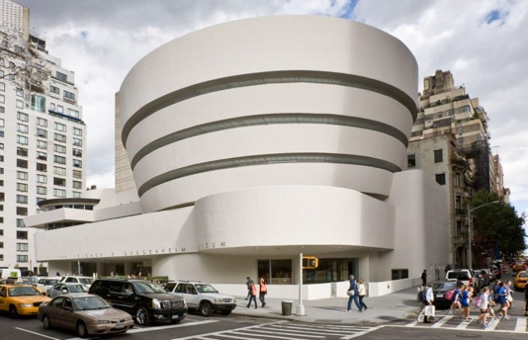  Guggenheim Museum | This museum near Central Park is home to an important collection of modern art. The collection is housed in a unique building designed by the renowned American architect Frank Lloyd Wright.  Days and Times: on Monday from 09:30 to 18.00; on Tuesday from 09.30 to 18.30; on Wednesday and Friday from 09.30 to 18.00; on Saturday from 09.30 to 20.30 and on Sunday from 09.30 to 18.00  Prices: For the adults $25; for the students and over 65 $18 and children under 12 free
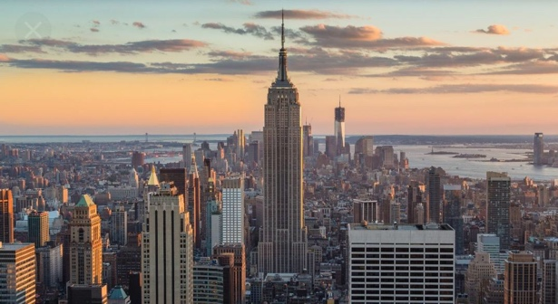  Empire State Building | A visit to the most famous skyscraper in the world is a must when you go to New York. From the top, you have a great view over Midtown and the rest of New York City.  Days and Times: Every day from 08.00 to 02.00 (di notte)  Prices: 102° e 86° floors= for the adults $64,20; for the over 62 $62,15; for the children (6-12 years ago) $58; under 6 years ago it's free.  Only 86° floor= for the adults $54,50; for the children (6-12 years ago) $46,10; it's free for the under 6 years old.
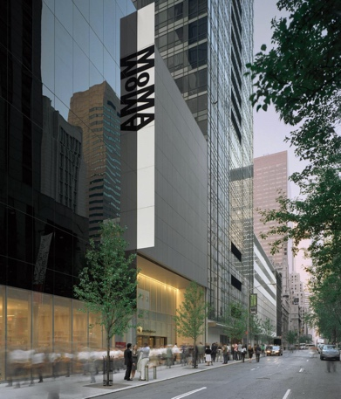  MOMA | This world-renowned museum opened in 1929 thanks to Abby Rockefeller. Today the museum has a large collection ranging from paintings over photographs and film to electronic media.  Days and Times: Every day from 10.30 to 20.00  Prices: for the adults $25; for the students with ID $14; for the over 65 with ID $18; free for the children under 16
9/11 Memorial  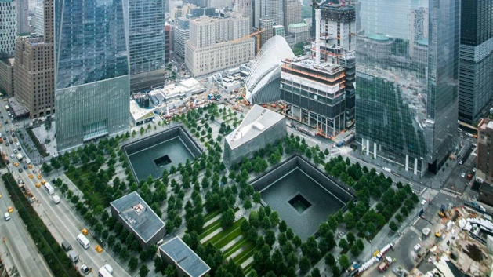 | A memorial plaza with two large recessed pools and cascading waterfalls commemorates the victims of the terrorist attacks on the World Trade Center in 2001.  Days and Times: The 9/11 Memorial is free of charge and open to the public daily from 7:30 a.m. to 9 p.m.  Prices: for the adults $24 (tour in the museum $44/ tour memorial $39); for the children 7-12 years ago $15 (tour in the museum $35/tour memorial $30); for the young adults 13-17 years ago $20 (tour in the museum $40/tour memorial $35); for the over 65 $20 (tour in the museum $40/tour memorial $35).
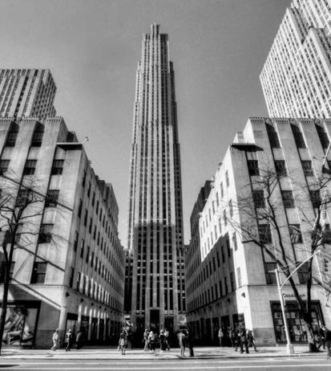  Rockefeller Center | Rockefeller Center, originally known as Radio City, is a complex of buildings developed in the midst of the Great Depression. Originally the complex consisted of 14 buildings, the 70 story RCA building being the tallest.  Days and Times: Every day from 07.00 to Midnight  Prices: for the “Top of the Rock” $30/36; for the “Rockefeller Center Tour” $25.
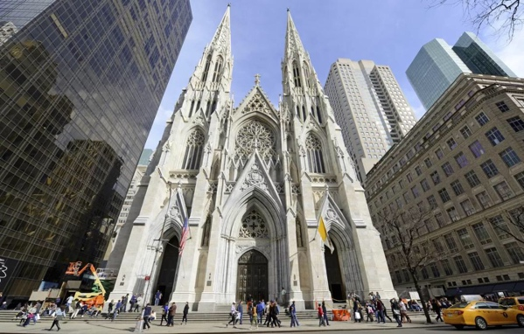  St. Patrick's Cathedral | St. Patrick's Cathedral completed in 1900, this neo-Gothic masterpiece is the country's largest Roman Catholic cathedral. It is located at Fifth Avenue near Rockefeller Center, now a posh area but at the time of construction well out of the city center.  Days and Times: Every day from 09.00 to 20.00  Prices: free
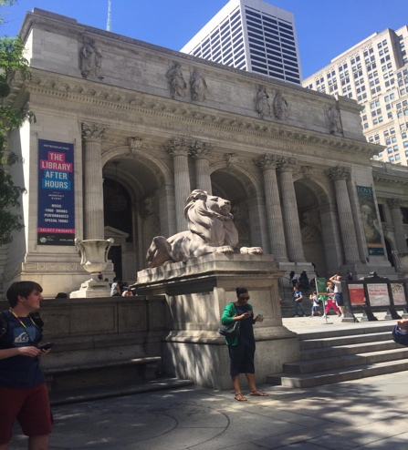  New York Public Library | One of the world's most acclaimed libraries is housed in a magnificent Beaux-Arts building, designed by architects Carrère and Hastings. The building was completed in 1911 after nine years of construction.  Days and Times: Every day from Monday to Saturday from 10.00 to 18.00, Sunday from 13.00 to 17.00.
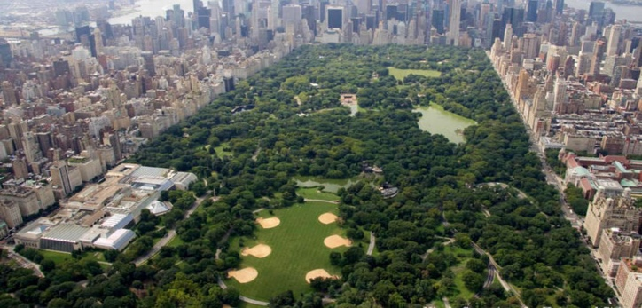  Central Park | Central Park was the first large city park in the United States. The design by Olmsted and Vaux has been copied all over the world. Originally situated in a sparsely populated area, the park is now surrounded by highrises.  In the central park there are more attractions like:  •Alice in Wonderland  One of Central Park's most cherished sculptures is a depiction in bronze of Alice and her friends, the characters from Lewis Carroll's Alice in Wonderland  •Balto  Balto the sled dog has nobly stood on a rock outcropping in Central Park since 1925. His statue, a big favorite in the Park, is located west of East Drive and 67th Street and north of the Zoo.
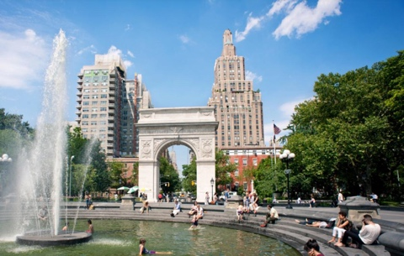  Washington Square park | Washington Square, located in Greenwich village, was laid out in 1826. Its main attraction is the Washington Arch, constructed for the centennial of President Washington's inauguration.  Days and Times: The park is open every day from 06.00 to 01.00
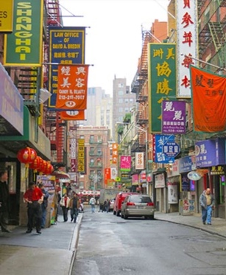  Chinatown | Chinatown  New York City’s unique ethnic neighborhood was founded in the 1870s by the Chinese immigrants. It is located in the lower portion of Manhattan, not far from other famous neighborhoods like Tribeca and Soho.
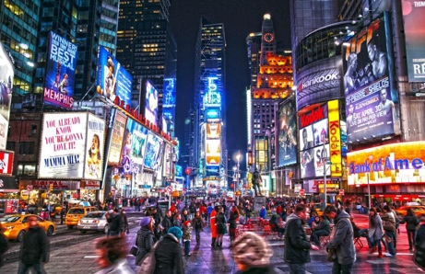  Times Square | Times Square, the most bustling square of New York is known for its many Broadway theatres, cinemas and electronic billboards. It is one of those places that make New York a city that never sleeps.
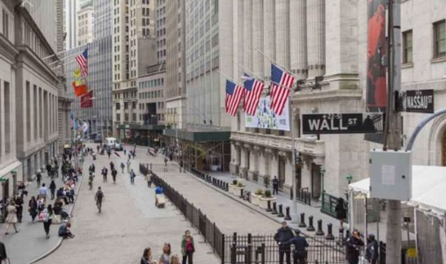  Wall Street | Wall Street, a small street in Lower Manhattan, is one of the world's most famous streets. Thanks to the stock exchange and the many banks here, the street embodies New York City's financial establishment.
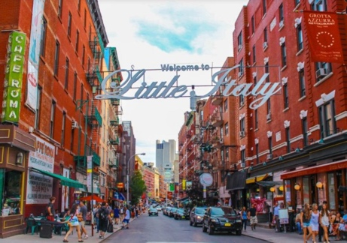  Little Italy | Little Italy  True to its name, very little is left of this once neighborhood once known for its many Italian immigrants who lived in overcrowded tenement houses. You still find some typical Italian restaurants in this neighborhood
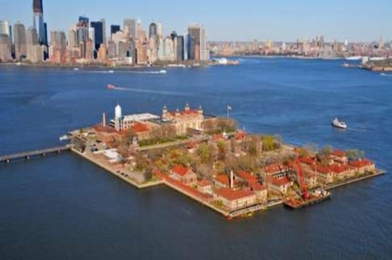  Ellis Island | Ellis Island  Now home to the immigration museum, Ellis Island was the immigrant gateway to America. More than 12 million people arrived here on the way to their new life in a new country
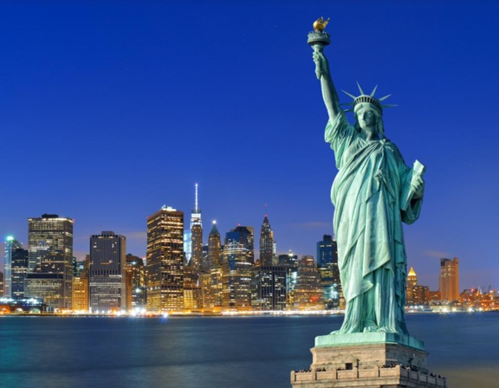  Statue of Liberty | Statue of Liberty  A short boat trip brings you from Manhattan to the Statue of Liberty, a gift from France for the centennial of America's Independence which now symbolizes the USA and New York in particular.  Days and Times: Every day from 08.30 to 17.00 (20-35min)  Prices: Departure from New York (Battery Park) or New Jersey (Liberty State Park) the price is for the adults (13-61 years ago) $18.50; for the children (4-12 years ago) $9; for the over 62 and senior $14

