LONDON’S MONUMENTS
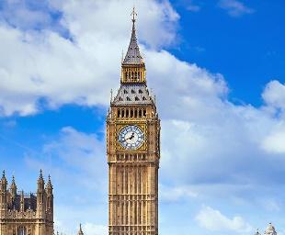 | The clock tower is situated in the north of the Palace of Westminster in London.  The ticket with a guided tour is £25.00  Is always possible to visit but is interesting to visit when the clock sing (every hours)
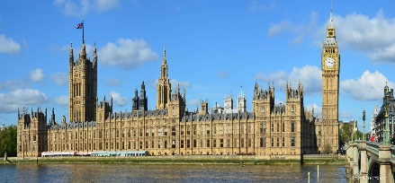 | The Westminster palace is the is the seat of the parliament  Is possible to visit only on Saturday and on the summer months  Price: for the adults is £18 or £28 (with the guide) and for the students £15.50 and £20
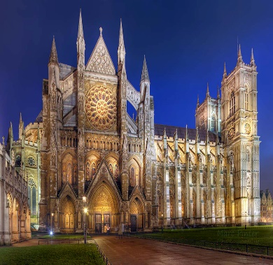 | The Westminster abbey is the second important place of worship Anglican in London, seat of the coronations of the sovereigns of England and of the burial of important people  Schedule: Monday, Tuesday, Thursday and Friday, from 9:30 am to 4:30 pm; Wednesdays from 9:30 to 19:00; Saturday from 9:30 to 14:30; Sunday closed for tourists.  Price: for adults £ 20, for students and over the age of 60: £ 17,  children from 6 to 16 years: £ 9 while for children under 6: free admission.  Free access with London Pass
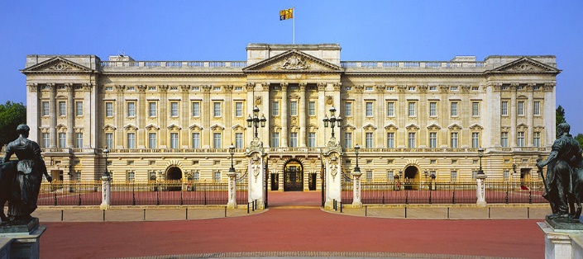 | Buckingham palace is the London residence and administrative headquarters of the monarch of the UK, the palace is often at the centre of state occasions and royal hospitality.  Is possible to visit only from 21 July to 2 October.  Schedule: from 21/07 to 31/08 from 9.30 to 19.00, from 1/09 to 31/10 from 9.15 to 18.00  Price: Buckingham Palace and State Halls:  Adults: £ 24.  Students over the age of 60: £ 22.  Children under 17: £ 13.50. Children under 5 years of age: free entry. Buckingham Palace, State Halls, Royal Stables and Queen's Gallery:  Adults: £ 42.30  Students over the age of 60: £ 38.50.  Children under 17: £ 23.30. Children under 5 years of age: free entry
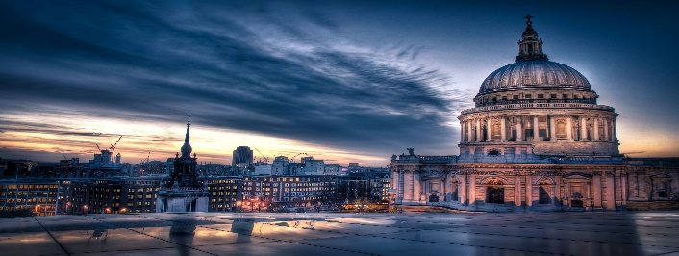 | The St. Paul’s cathedral is the second largest cathedral in the world  Schedule: From Monday to Saturday  8:30 am: Doors open for sightseeing  9:30 am: Galleries open for access  4pm: Last entry  4:30pm: Cathedral closes  Price: Adults: £18.  Students and seniors (over 60): £16  Children (ages 6 to 17): £8
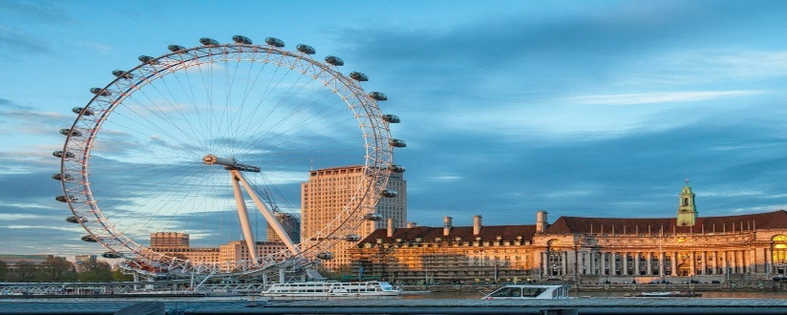 | The London eye is a design, engineering and architectural sensation and has become one of the city’s top attractions and emblematic icons.  Schedule: January - March: 11 am - 6 pm  April and May: opening times vary depending on the day but usually one of two schedules applies - 11am to 6pm or 10am to 8:30pm  June, July and August: 10 am - 8:30 pm  September to November: 11 am - 6 pm  December: The majority of the month opening times are 11am to 6pm but between 21st December and new year times vary depending on the day.  Price: Adults: £27.00  Children (ages 4 to 15): £19.80  Children (less than 3): free entrance
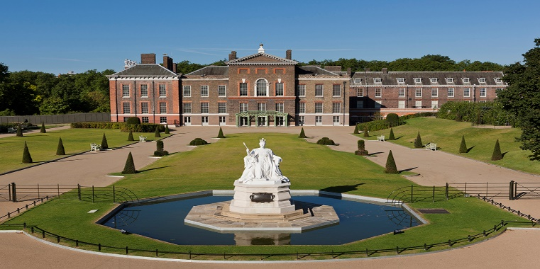 | Kensington Palace has been home to several generations of the British Royal Family, from King William III to Queen Victoria and Princess Diana.  Schedule: March to October: 10 am to 6 pm. (last admission 5pm)  November to February: 10 am to 4 pm. (last admission 3pm)  Price: Peak Adults: £19.50  Students: £15.50  Children: £9.70  Off Peak Adults: £16.00  Students: £12.70  Children: £8.00
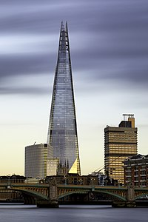 | The Shard, formerly known as the London Bridge Tower, is Europe’s tallest skyscraper, standing 309.6 meters. This impressive skyscraper has transformed London’s skyline permanently.  Schedule: Thursday – Saturday:10 am to 10 pm (access until 8:30 pm).  Sunday – Wednesday: 10 am to 7 pm (access until 5:30 pm).  Closed on 25 December.  Price: Adults: £24.50  Children (ages 4 to 15): £19.95  Children (less than 4): free entrance
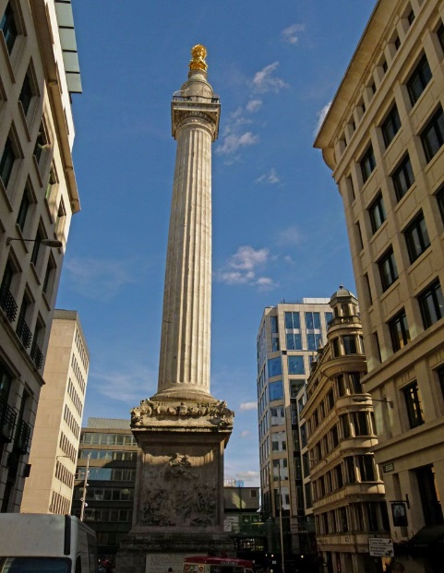 | The Monument to the Great Fire of London was built to commemorate the victims of the Fire and celebrate the reconstruction of the city.  Schedule: April – September: 9:30am - 6:00pm(last admission 5:30pm)  October – March: 9:30am – 5:30pm (last admission 5:00pm)  The Monument is closed from 24 – 26 December.  Price: Adults: £4.50  Children (5-15 years old): £2.30  Students and Seniors: £3  The Monument + Tower Bridge: £11. (Students: £7.50)  Free entry with the London Pass.
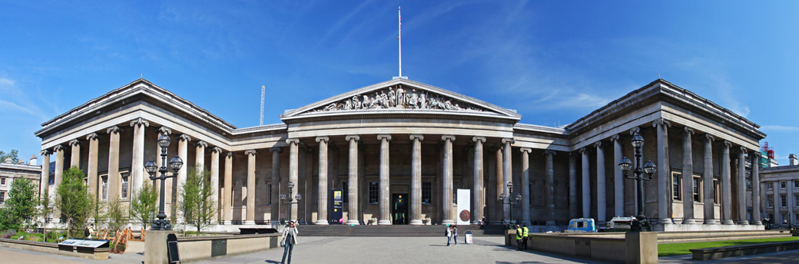 | The British museum is the largest collection of antiques and objects of historical interest in the world.  Times: every day from 10.00 to 17.00  On Friday from 10.00 to 20.30  Price: free entry
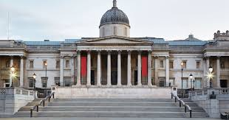 | The National gallery has got the most important of collection of painters, from Middle Age to Impressionism, of Botticelli, Michelangelo, Caravaggio, Van Gogh, Raffaello, Leonardo Da Vinci.  Times: every day from 10.00 to 18.00  On Friday from 10.0 to 21.00  Price: free entry
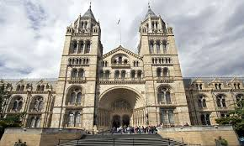 | The Natural History museum is divide in 5 area: zoology, mineralogy, palaeontology and entomology.  Times: every day from 10.00 to 17.50  Price: free entry

