PARKS IN AMERICAN
Days: from 01/09 to 15/09 (15 days)

Flight: from Milano Malpensa (MXP) to Los Angeles (LAX) departure at 06.40 arrive at 11.45 with Airitaly.
From San Francisco (SFO) to Milano Malpensa (MXP) departure at 10.05 arrive at 15.05 with a connection to Barcellona (BCN), with Iberia
Price: 500€+300€= 800€

Parks and accommodation:
- Montezuma castle national monument => Ylang Ylang Beach Resort
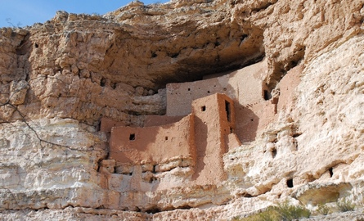
(120€ for one night for two persons)

- Grand Canyon => Holiday inn express Grand Canyon
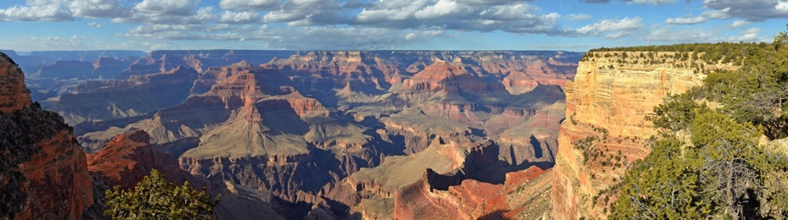
(260€ for two nights for two persons)
- Lake Powell => Lake Powell resort
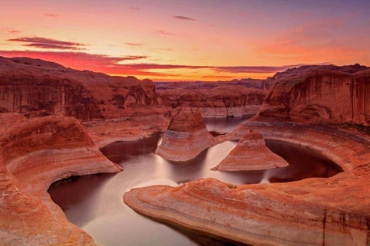
(250€ for two nights for two persons)
- Antelope Canyon => Amangiri
(150€ for one night for two persons)
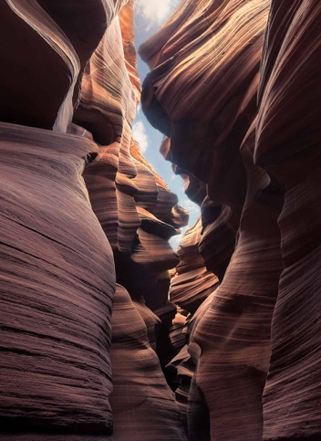

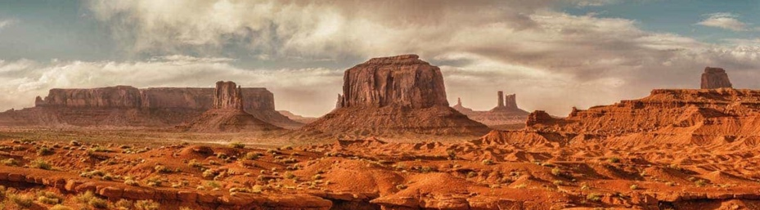
- Monument Valley => Camping in the valley
- Mesa Verde => Mesa verde lodging experience
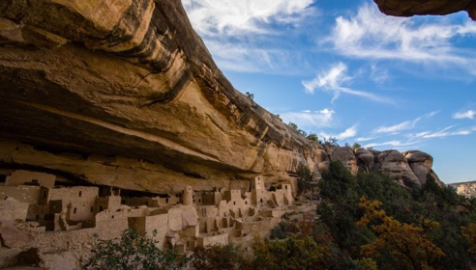
(150€ for one night for two persons)
- Moab Park => Moab Hotels
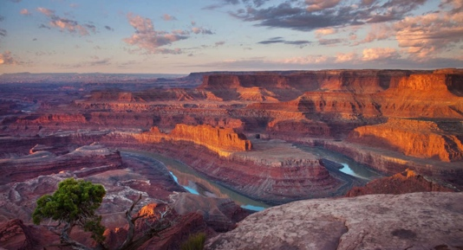
(260€ for two nights for two persons)
- Capital Reef => Camping capitol reef
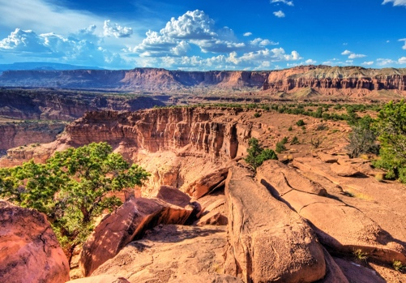
(130€ for two nights for two persons)

- Arches National Park => 57 Robbers Roost
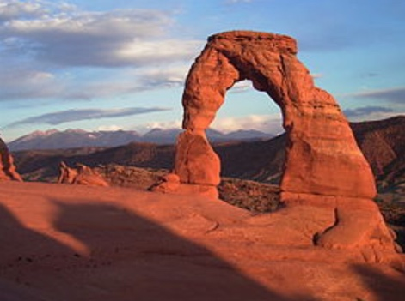
(182€ for two nights for two persons)

Distance: From Los Angeles to Montezuma Castle National Monument 6 hours
From Montezuma Castle National Monument to Grand Canyon 2 hours and 15 minutes
From Grand Canyon to Lake Powell 2 hours and 31 minutes
From Lake Powell to Antelope Canyon 21 minutes
From Antelope Canyon to Monument Valley 1 hours 51 minutes
From Monument Valley to Mesa Verde 2 hours 10 minutes
From Mesa Verde to Moab Park 2 hours 45 minutes
From Moab Park to Capitol Reef 2 hours 20 minutes
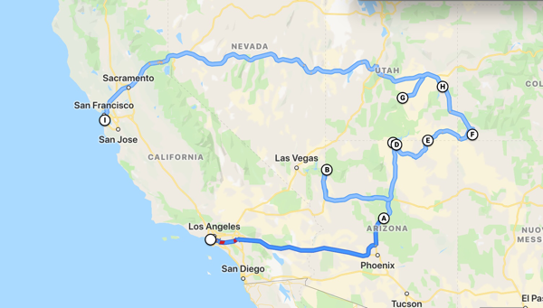
From Capitol Reef to Arches National Park 2 hours 23 minutes
For a total 33 hours 58 minutes

